Strain gauge experiment
Name
Institution
Class

Abstract:
A strain gauge is a tool in engineering and physics. It measures the effect of external force on objects by directly measuring strain and thus enables the determination of torque, deflection, pressure, and most importantly the stress on an object. The strain gauge converts physical quantities such as tension, pressure, and weight to electrical resistance. The resistance of the gauge depends on the geometry of its conductor; it is thick when compressed and it is thin when stretched. The length of the resistance and the cross-sectional area of the conductor are important geometrical aspects that affect the resistance of the strain gauges’ resistor. When force is applied on the conductor alters its lengths and cross-sectional are and this consequently affects its resistance. A strain gauge sensitivity factor also called the coefficient of the strain gauge is an important characteristic t of the strain gauge. It is measured using the Wheatstone bridge. To measure the resistance of the conductor, the Wheatstone bridge which is an equivalent voltage to a pair of parallel dividers is used and in the case of strain measurement, one of the four restitaorsR1, R2, R3 and R4 is replace with a strain gauge, even the slightest changes are reflected in the voltage output and thus can be measured. These changes are independent of temperature and if temperature affects the changes the thermistor manages them. These apparatus are easy to maintain and have a simple principle of operation. They are thus used in aerospace to measure torque, equipment power, monitoring of strain on equipment and objects.

Introduction:
The strain gauge is an important technical tool that is used in different areas that range from geotechnical industries, power plants, refineries, generators and propellers among many others. This equipment is simply a sensor whose resistances vary with the force applied on it. The strain gauge works on a super simple principle; converting quantities such as pressure, weight, tension, and force into changes in electrical resistance which is measurable. When a force is applied on an object, it results in strain and stress. The stress and strain on the stationery objects leads to deformation and this deformation leads to deformation of the conducting foil and thus consequently leading to change in the conductor’s resistance. The change in resistance is measured by the Wheatstone bridge which is an equipment relate to the strain gauge by the gauge coefficient.
A strain gauge is composed of an insulated metal foil, two lead that enable current to pass through the gauge as the strain and stress is applied on the surface off an object to produce stretches and contractions that cause changes in electrical resistance that is measured (Encardio Rite, 2019). The equation for the strain gauge factor is as shown;
K. ε = ΔR/R
R= resistance, ΔR= charge in resistance, ε= strain and K=gauge factor
A strain gauge experience forces as shown in below;
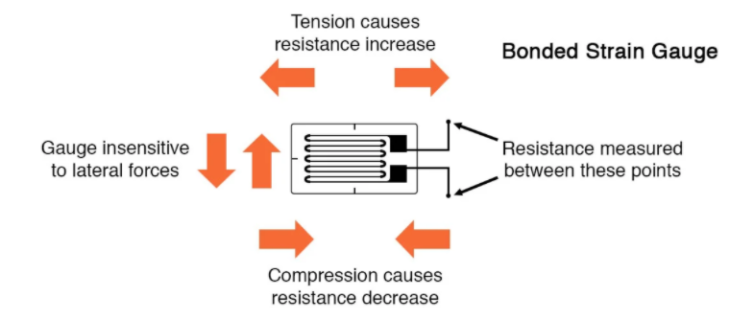
Figure 1; Structure and forces acting that acting on strain gauge
Based on its working principle of electrical conductance impacted by geometrical aspects such as length and cross-sectional area, its conductor stretches past it elastic limits to become thinner and longer and gets shorter ad thicker when compressed. A Wheatstone bridge is a four resistance interfering tool that helps calculate the change in resistance. The bridge output potential is n din the equation
Vo = [(R3/R3+R4) — (R2/R1+2)] * Vex , R1-R4 are the Wheatstone bridge resistors’ resistance
There are two types of bridge interference arrangement; the half-bridge and the full—bridge.
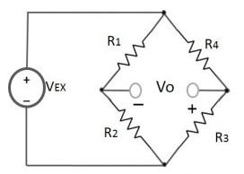
Figure 1.2; the structure of the Wheatstone bridge
Resistance is depend to geometrical properties of the conductor
R=L/A where ; R = Resistance, L = Length and A = Cross-Sectional Area.
A force applied on the conductor alters its length and cross-sectional area and thus lead to a change in resistance. For a change in length from initial length Li to final length Lf,
The strain ε= (Li- Lf)/Li

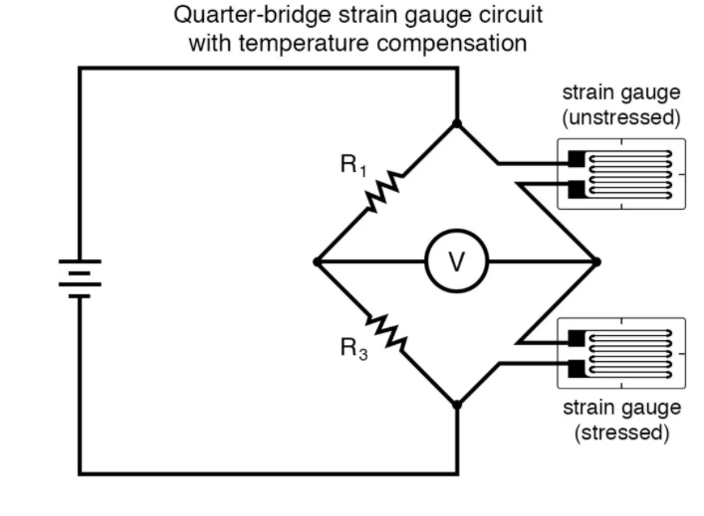
This is the most used circuit in measuring strain because it is impossible to bound a pair of complimentary train gauge in testing.
Figure 1.3: The quarter bridge circuit
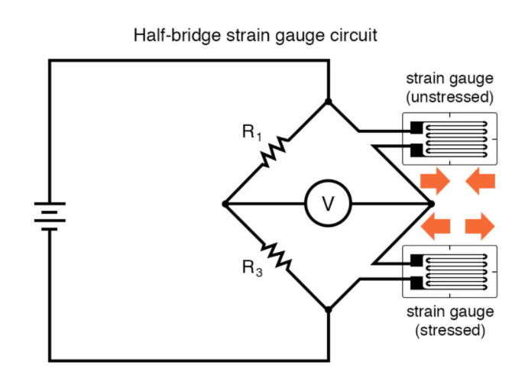
Figure 1.4: The half-bridge circuit
The full-bridge circuit is and shown below
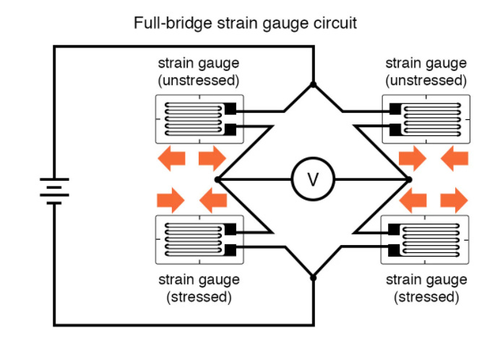
Figure 1.5: The full-bridge circuit
The strain gauge change I resistance is measured in a bridge circuit for greater precision and to limit temperature related resistance variations.
Literature review:
A strain gauge is an instrument that coverts physical quantities (stress, strain, pressure, weight and force) of the force applied on an object to electrical signals through changes in resistance for strain measurement. Although the strain gauge Wheatstone circuit measures strain, there are other methods that are used to measure these deformation such as the use of thin-film strain gauges, semiconductor strain gauges, photoelectric gauges and the extension meter among others. There are different types of strain gauge that include (Encardio Rite, 2019);
- The Ly linear strain gauges that are used to measure strain in one direction and are distinguished by their geometrical properties such as gauges and properties.
- The membrane rosette strain gages that are used in measurement of velocity, pressure, force and displacement and elastic strain for materials that are usually under static and dynamic loads. These gauges are used in mechanical engineering, aeroplanes, cars and train manufacturing industries.
- The rectangular rosette strain gauge which has three elements and three grids for trsin measurements
In terms of their combined circuit with a Wheatstone bridge, strain gauge scan be classified as either type I and type 2 full bridge circuit gauges of type I and type Ii half-bridges.
2.1 the thin film strain gauge
This is an advanced gauge that is made by depositing an electrical insulator on a metallic surface e that is stressed and placing the strain gauge on the layer of insulation. Due to their high precision, thin film strain gauges are used in the production of precision resistors that are ultra-stable.
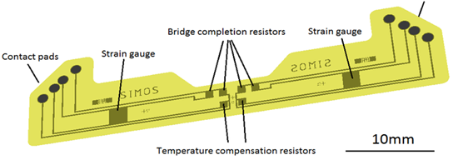
2.2 The semiconductor strain gauge
These gauges are produced majorly for use in the car industry. The semiconductor strain gauge utilizes the piezo resistive impacts on material such as germanium and silicon. They thus measure the variation of resistance and strain and are used in diodes, radiation detectors, thermometer, and solar batteries sand transistors.
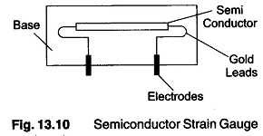
Figure 2.2: Semiconductor Strain Gauge
2.3 Metallic wire strain gauge
This gauge is build duding wire connections with supper thin wires that are attached by a thin layer of epoxy resin to a strained surface. The metallic wire gauge measures strain in terms of electrical resistance of the wires.
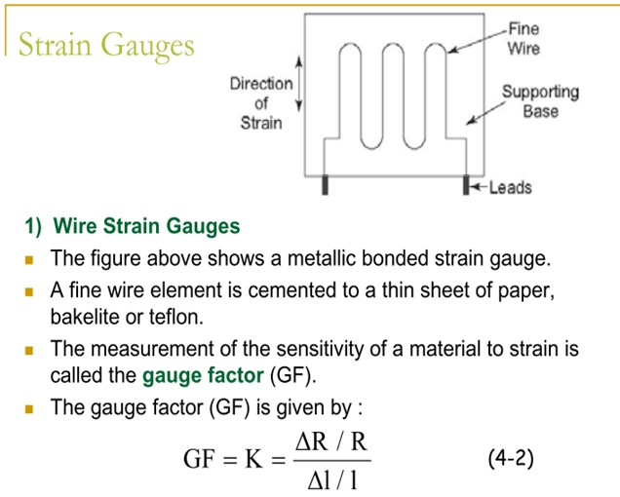
Figure 2.3: Metallic wire strain gauge
Paired with a Wheatstone, strain gauges are applied in aerospace in excitation power supply, reading on in situ measurements, and also used in on board signal conditioning units. Additionally strain gauges help in monitoring bridge cables, monitoring railroads, measuring power and torque in rotating objects and test vehicles (Encardio Rite, 2019).
References
Encardio Rite, "Strain Gauge”, Strain Gauge: Principle, Types, Features and Applications, united states, July 3, 2019
Strain Gauge: Working Principle & Diagram https://www.electrical4u.com/strain-gauge/. October 2020.

